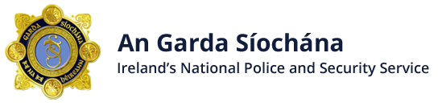

Business Watch Scheme
The Gardai in Athlone, in conjunction with the Athlone Chamber of Commerce, intend to establish a Business Watch Scheme for the town of Athlone and its environs.
The Business Watch Scheme is designed to provide you and/or your employees, information of recent crime trends and to develop a text alert system that works on the same principles as a Neighbourhood Watch.
The core principle of this Business Watch Scheme is to reduce thefts, damage and other anti-social behaviour, which all have an impact on the viability and sustainability of businesses in Athlone.
If you have any interest in the Athlone Business Watch Scheme, please fill in this form and email the Crime Prevention Officer at westmeath.crimeprevention@garda.ie

- Name of the Business: *

- Name of the Business Owner: *

- Contact Phone Number: *

- Email Address (Optional): *

Following your email, Sergeant John McWalter will be in contact with you regarding the launch of the Business Watch Scheme.

